Service-CNC Turning
Demo knowledge file for Content Studio | CNC Turning
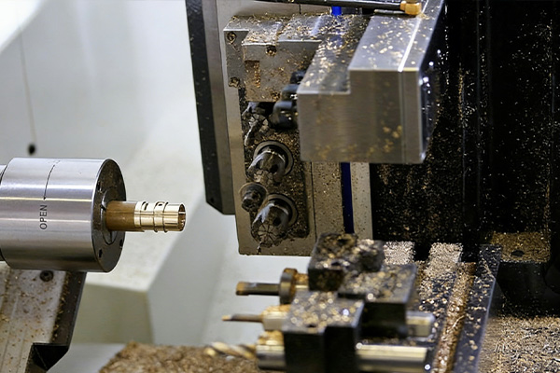
Representative image for CNC Turning service content.

Service Summary
Precision turning service for shafts, sleeves, fasteners, knobs, and other rotational metal components.
Expert CNC turning and Swiss screw machining for complex, high-volume parts. Request a turning quote for precision cylindrical components.

Typical Applications
- Shafts and pins
- Threaded fasteners
- Audio knobs
- Sleeves and bushings
- Cylindrical connector parts

Material Coverage
- Aluminum
- Stainless steel
- Brass
- Copper
- Engineering plastics

How Content Studio Should Use This File
- Use this service summary as source material for service pages, blog articles, landing pages, and RFQ-oriented email copy.
- Use the applications list to match service content with buyer scenarios and AI-generated article sections.
- Use the source URL when the generated content needs traceable evidence or a reference link.

Crawled Page Headings
- Service
- CNC Turning
- Find Content
- Explore
- Get In Touch
Source: https://www.rejincnc.com/service/cnc-turning/

